**JKUAT- KSA Small Scale Agriculture Crop Mapping Project**

**Study Area Research**

**STUDY AREA**

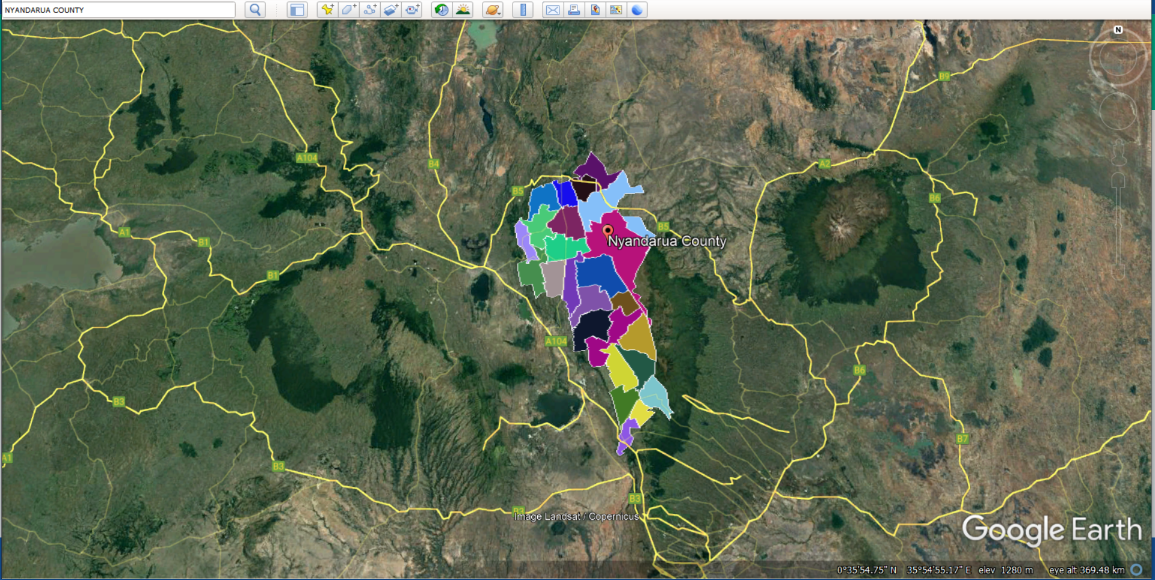

NYANDARUA COUNTY

Nyandarua County is a county in Kenya's former Central Province, located in the northwestern corner of the country and home to the Aberdare Ranges. Its capital and largest town is Ol Kalou with a population of 596,268 and an area of 3,304 km2. This county lies in the latitudinal extents between 0o 09’ N and 0 o 57’ S of the Equator and in the longitudinal extents between 36o 06’E and 36 o 52’ E of the Prime Meridian

The electoral constituencies are Kinangop, Kipipiri, Ol’ Kalou, Ol Jorok and Ndaragua having Ol Kalou, Engineer, Ndunyu Njeru, Murungaru Shopping Center, Gwathukia, Kwa Haraka Trading Center, Kirima Shopping Center, Karangatha Shopping Center, among others, as the most famous urban areas.

Nyandarua County is a productive area for agriculture, manufacturing and processing but the main economic activity is farming (crop cultivation and dairy farming). Agriculture and trade are the backbones of Nyandarua's economy, thanks to excellent soils and a pleasant environment. Nyandarua is known as Kenya's food basket, with high output of potatoes, cabbages, carrots, peas, and milk. Farmers (about 100,000 farm families) make up the vast majority of the population, who are involved in the production of Irish potatoes.

The Nyandarua County was chosen due to its closeness to Kenya’s weather conditions as well as its small scale farming productivity. It has an average annual temperature of 25° with that of Kenya ranging between 20°C and 28°C. A favorable study area temperature would be considered to be at 24°C, thus Nyandarua would prove sufficient in its temperature conditions. Additionally, Nyandarua’s rainfall is estimated to be 574 mm annually, with Kenya’s average rainfall standing at 680mm. The county is best known for Potato production mostly in Kinangop and Engineer sub counties. The county has Aberdare ranges having several tributaries from rivers such as Malewa and Mikeu which provide water for irrigation. There is also Lake Olbossat which provides water to farmers on the leeward side of the ranges. There is still potential for expansion within the surrounding areas having fertile soils. However, this is constrained by lack of sufficient water for irrigation in those areas. This area is largely plane and predominantly covered with black cotton soils with a few spots of red soil. Potatoes have been planted developed on the low areas that are covered with black cotton soils while the high spots covered with red soils have been reserved for settlement and production of upland crops such as cabbages, carrots and peas.